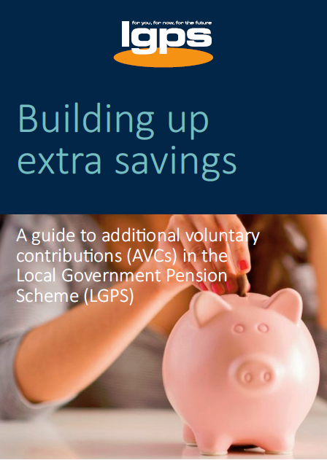
AVCs – a summary
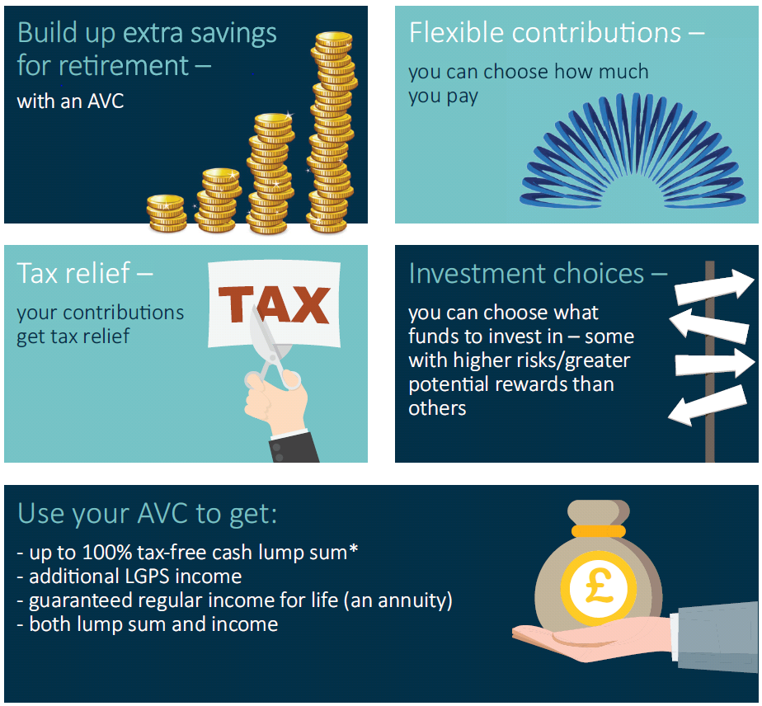
* Conditions apply.

What are AVCs?
AVCs allow you to pay more to build up extra savings for your retirement.  When you save AVCs you pay money into a separate AVC plan, in addition to the main Local Government Pension Scheme (LGPS). You build up a pot of money which is then used to provide additional benefits to your main LGPS benefits.  Your AVC plan becomes payable when you take your main LGPS benefits.  All local government pension funds have an arrangement with an AVC provider (often an insurance company or building society) in which you can invest money in funds managed by the AVC provider. These arrangements are known as in-house AVCs and are referred to as just AVCs in this guide.  AVC contributions are deducted directly from your pay before your tax is worked out, so, if you pay tax you receive tax relief automatically.  The amount of tax relief you receive |  | depends on whether you are a basic,  higher or additional rate taxpayer. If you don’t pay tax, you won’t benefit from tax relief.  You have your own personal account that, over time, builds up with the contributions you pay in. The amount in your account depends on how long you pay AVCs for, the impact of charges and how well the fund(s) you invest in perform. You choose how the money in your AVC plan is invested.  Your AVC plan is an investment and the value can go down as well as up so you may not get back what you put in.  You can pay up to 100% of your pensionable pay¹ (subject to other deductions made by your employer) into an AVC. You may wish to get independent financial advice about taking out an AVC.  If you are interested in paying AVCs, you should contact your pension fund for further information.
How do AVCs work?
How much can I pay in?  You can pay up to 100% of your pensionable pay (subject to other deductions made by your employer) into an AVC.  Flexible contributions  You can choose to pay a fixed amount or a percentage of your pay, or both, into an AVC – as long as it does not exceed 100% of your pay.  AVCs are deducted from your pay, just like your normal pension contributions. Deductions start from the next available pay period after you’ve set up the AVC. You may vary your contributions or cease payment at any time while you are paying into the LGPS.  You can pay an AVC if you are in either the Main or 50/50 section of the LGPS.  AVCs and extra life cover  You can also pay AVCs to provide extra life cover. Your membership of the LGPS already gives you cover of three times your assumed pensionable pay² if you die in service, but you can pay AVCs to increase this and provide additional benefits for your dependants if you die in service. Any extra cover you buy will stop when you take your LGPS benefits or leave.  Get tax relief  Your LGPS and AVC contributions are deducted before your tax is worked out, so, if you pay tax, you receive tax relief automatically through the payroll. | Although most people will be able to save as much as they wish into an AVC, the amount of pension tax relief you can receive is limited. See the ‘Tax Controls and Your Pension’ section at the end of this booklet for more information.  How the tax relief works:  AVC contributions are taken from your pay before tax. Any money you would normally pay as income tax automatically goes into your AVC pot instead as you can see below. If you pay tax at a higher rate, your tax savings will be higher. If you don't pay tax, you won't benefit from tax savings.
 | For a basic rate tax payer
 | 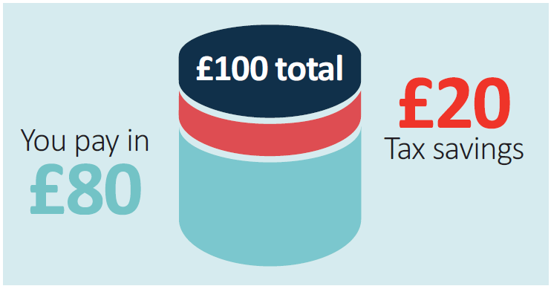
 | A £100 investment in your plan only costs you £80
 | For a higher rate tax payer
 | 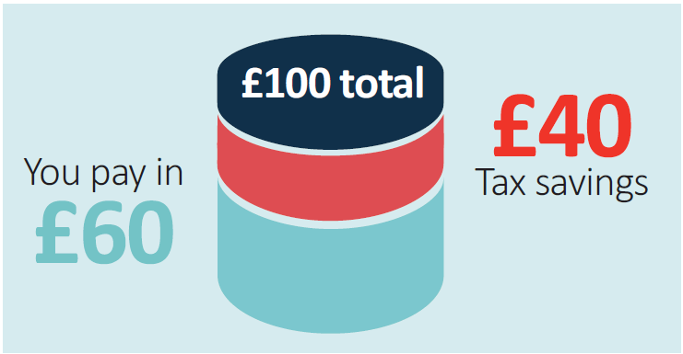
 | A £100 investment in your plan only costs you £60

How you save with an AVC  The AVC provider will set up your own personal account. Your account builds up over time with your contributions and any investment returns you make.  The amount in your account will depend on how long you pay AVCs for, the impact of charges and how well the fund(s) you invest in perform.  You choose how the money in your AVC plan is invested. The investments on offer will have varying risk levels – the higher | the risk, the higher the potential rewards. The lower the potential rewards, the lower the risk. You may be able to spread your investments (and risks) over a number of investment areas such as equities (shares), bonds, property and cash. Each have their own risk/potential rewards.  As with all investments, the value may go up or down and you may not get back what you put in.

What can I do
with my AVC?
This section outlines how you can use your AVC plan in the LGPS and the option of transferring your AVC plan to a different pension arrangement.  When you take your main LGPS benefits, you can use your AVC to:  - Buy a regular income that is guaranteed to be paid for the rest of your life  You can use your AVC plan to buy a lifelong, regular income (also known as an annuity) that’s guaranteed to be paid for as long as you live. Annuities offer different features which may be of interest to you, such as improved terms if you are in poor health and annual increases to keep up with the cost of living.  When you buy an annuity, you can usually take some of your AVC plan as a tax-free lump sum at the same  time and use some or all of the balance to buy an annuity. An annuity is paid completely separately from your LGPS benefits.  The amount of annuity depends on several factors, such as interest rates and your age. As a rule of thumb, the older you are when you take out an annuity, the higher the income you’ll get. You also have some choice over the type of annuity, for example, | whether you want a level annuity that provides a higher income to start with, but the payments will stay the same for life, or an escalating annuity that will start at a lower rate but will increase over time to keep up with the cost of living. You can also choose whether you want to provide for dependants’ benefits in the event of your death.  You don’t have to buy an annuity from your AVC provider – it’s really important that you shop around to get the best ‘annuity rate’ based on your personal circumstances and the annuity features you’re looking for.  You would normally buy an annuity at the same time as you take your main LGPS benefits. However, if you left  the LGPS before 1 April 2014, you can leave your AVC plan invested and use it later.  - Buy a top-up LGPS pension  If you paid into the LGPS on or after 1 April 2014 you can use some or all of AVC plan to buy extra pension  from the LGPS. The extra pension you buy will increase in line with the cost of living.  Your dependents will automatically be provided with extra pension in the event of your death.

- Take some or all of your AVC as a single tax-free lump sum  You can take some or all of your AVC plan as a tax-free lump sum, provided that:  - When added to any lump sum you take from your main LGPS benefits, the total tax–free lump sum does not exceed 25% of the overall value of your LGPS benefits you are taking at that particular time (this includes the value of your AVC plan).  - Your maximum tax-free lump sum does not exceed 25% of the lifetime allowance (£263,750 for the tax year 2019/20) or 25% of your remaining lifetime allowance³, if you have previously taken payment of any benefits.  - Buy extra membership in the LGPS  This only applies if you started paying into your AVC plan before 13 November 2001.  If this was the case, you may be able in certain circumstances (such as flexible retirement, retirement on Ill-health grounds, or on ceasing payment of your AVCs before retirement) to convert your AVC plan into extra LGPS membership in order to increase your LGPS benefits. | The extra membership will attract a pension of 1/60th of your final pay for each year of membership purchased.  - Leave your AVCs invested and use them later…  …but only if you left the LGPS before 1 April 2014  If you left the LGPS before 1 April 2014, you can choose not to take your AVC plan when you take your main LGPS benefits. You can leave your AVC plan invested and use it at a later date; however, you must take it by the age of 75.  If you do not take your AVC plan at the same time as your main LGPS benefits, you will be restricted to taking 25% of your AVC plan as tax-free cash and buying an annuity with the remainder when you do draw it.  If you paid into the LGPS on or after 1 April 2014, you must take your AVC plan at the same time as you take  your main LGPS benefits.  - You may be able to transfer your AVC fund to another pension scheme or arrangement  You can transfer your AVC plan to one or more different pension arrangements even if you are still an active member of the main LGPS scheme. However, you must stop paying AVCs in any LGPS employment you hold before you can

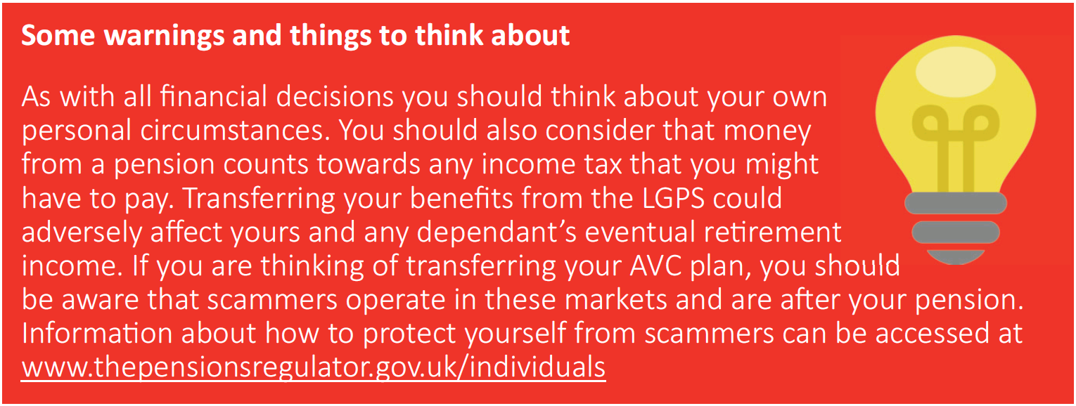
transfer your AVC plan. If you hold more than one AVC plan you must transfer all of your plans (even if they are held with different LGPS funds).  Different pension providers offer different options in relation to what you can do with your AVC, including the option to buy regular income (an annuity). By transferring out to one or more different pension arrangements you may be able access options that are not available under the LGPS rules, such as:  - take a number of lump sums at different stages – usually the first 25% of each cash withdrawal from your pot will be tax-free with the rest subject to tax.  - take the entire pot as cash in one go – usually the first 25% will be tax-free with the rest subject to tax. Remember, it is possible to take all of your LGPS AVC plan as a tax-free lump sum, subject to certain conditions, if you leave it in the LGPS and take it at the same time as your main LGPS benefits. | - to provide a flexible retirement income – this is known as flexi-access drawdown. You are normally allowed to take a tax-free lump sum of up to 25% then set aside the rest to provide taxable lump sums as and when, or a regular taxable income.  There may be tax implications associated with accessing your benefits in the ways described above. The income from a pension is taxable; the rate of tax you pay depends on the amount of income that you receive from a pension and from other sources.  The different options mentioned above have different features, different rates of payment, different charges and different tax implications.

Get some advice…  Deciding how to use your AVC plan is one of the most important financial decisions you are likely to make. We recommend that you get guidance and/or independent financial advice to help you decide which option is most suitable for you.  Pension Wise is a free, impartial service offered by the Government to provide guidance, once you reach age 50, to help you understand your defined contribution pension options (eg AVCs). You can find out more at www.pensionwise.gov.uk or by calling 0800 138 3944 to book a phone or face-to-face appointment.  Independent financial advice  Help with finding an independent financial adviser is available at www.moneyadviceservice.org.uk  The Money Advice Service offers free and impartial money advice, including pensions and retirement information. www.moneyadviceservice.org.uk  The Financial Conduct Authority (FCA)  is the regulatory body for independent financial advisers.  www.fca.org.uk | The Personal Finance Society is the professional body for financial advisers. It provides access to appropriately qualified members who commit to the highest professional and ethical standards. www.findanadviser.org  Unbiased is a website listing regulated and independent financial advisers, mortgage brokers, solicitors and accountants. It checks that everyone is registered with the Financial Conduct Authority (FCA).  www.unbiased.co.uk

Other considerations

What happens to my AVC if I take flexible retirement?

If your AVC plan started before 13 November 2001, your AVC contract will cease when you flexibly retire and you will have to use your entire AVC plan in one of the ways outlined earlier in this leaflet at the same time you take your flexible retirement benefits.

If your AVC plan started after 13 November 2001, you can choose to take none, some or your entire AVC plan in one of the ways outlined earlier in this leaflet, and if you wish, continue paying AVCs.

What happens to my AVC if I leave before retiring?

If you leave before retirement, your contributions will cease when you leave. The value of your AVC plan will continue to be invested until it is paid out. Your AVC plan can be transferred to one or more different pension arrangements or taken at the same time as your LGPS benefits.

What happens to my AVC if I die before taking it?

If you die before taking your AVC plan, it will be payable as a lump sum. Your AVC provider will pay the amount due to your LGPS administering authority who will then make payment in accordance with the scheme rules.

If you have elected to pay AVCs for the purchase of life cover, a death in service lump sum and/or dependents’ pension will be payable.

I have previous AVCs with the LGPS. Can I transfer them if I re-join the LGPS?

If you have paid AVCs to the LGPS in England or Wales, the accrued (built up) value of your AVCs must normally be transferred to an AVC arrangement offered by your new LGPS administering authority, if you combine your main scheme benefits.

Shared cost AVCs (SCAVC)

A shared cost AVCs is an AVC plan arranged through the LGPS (ie an in house AVC) that both you and your employer contribute to. Your employer can choose if they wish to offer SCAVCs.

Other ways to increase your pension benefits

Buy extra pension in the LGPS – additional pension contributions (APCs)  If you are in the main section of the LGPS, you can pay additional contributions to buy up to £7,026 (for 2019/20) of extra pension. You can choose to pay for the extra pension by spreading the payment of  the additional pension contributions (APCs) over a number of complete years or by paying a lump sum.  See the national LGPS member website for more information on APCs – www.lgpsmember.org  Tax relief is available on all pension contributions up to 100% of your taxable earnings.  Freestanding additional voluntary contributions (FSAVCs)  These are similar to in-house AVCs but are not linked to the LGPS in any way. With FSAVCs, you choose a provider, usually an insurance company. You may want to consider their different charges, alternative investments and past performance when you do this.  You choose how much to pay into an FSAVC arrangement. You can pay up to 100% of your UK taxable earnings, less your normal pension contributions.  How much income your FSAVC will provide depends on how long you pay AVCs for, the impact of charges and how well the fund(s) you invest in perform. Your AVC plan is an | investment and the value can go down as well as up, so you may not get back what you put in. You can choose which investment route you prefer.  You can usually take up to 25% of the value of your FSAVC fund as a tax-free lump sum.  You can also pay FSAVCs to provide additional life cover. Your LGPS membership already gives you cover of three times your assumed pensionable pay if you die in service, but you can increase this amount via an FSAVC or use the FSAVC to provide additional dependants’ benefits on your death in service. This may be subject to satisfactory completion of a medical.  Personal or stakeholder pensions  You can make your own arrangements to pay into a personal pension plan or stakeholder pension scheme at the same time as paying into the LGPS. With these arrangements, you choose a provider, and again, you need to consider their charges, alternative investments and past performance when you do this.  It is advisable to get financial advice before taking out any form of additional pension saving.

Tax controls and your
Pension

One of the benefits of saving with a registered pension scheme, such as the LGPS, is that you receive tax relief on the contributions you pay into the scheme. However, the amount of pension tax relief you can receive is restricted by Her Majesty’s Revenue and Customs (HMRC).  Most people will be able to save as much as they wish as their pension savings will be less than the allowances. However, if you are thinking of making additional pension savings, such as AVCs, it is important that you are aware of the restrictions.  Limits on how much you can pay  At the present time, whilst there is no overall limit on the amount of contributions you can pay, tax relief will only be given on contributions up to a total of 100% of your taxable earnings in a tax year (or, if greater,  £3,600 to a 'tax relief at source' arrangement, such as a personal pension or stakeholder pension scheme). | Limits on how much pension you can build up  The two controls set by HMRC are the annual allowance and the lifetime allowance.  1) Annual allowance  This is the amount by which the value of your pension benefits may increase in any one year without you having to pay a tax charge. For the 2019/20 tax year, the standard annual allowance is £40,000. However, if you are high earner your annual allowance could be lower than £40,000 due to ‘tapering’.  For money purchase arrangements, such as AVC schemes, the annual allowance you use is worked out by adding the total contributions paid by you, or on your behalf, over the tax year.  For defined benefits arrangements, such as the main LGPS scheme, the amount of annual allowance is determined by working out the growth in the value of your pension scheme over the tax year.  Your LGPS pension fund will inform you if your LGPS pension savings exceed the standard annual allowance in any year by no later than 6 October of the following year.  You can find out the value of your increase in pensions saving for each of the last three years by asking your scheme for a Pension Savings Statement.
For more information about the annual allowance, including information on ‘tapering’ for high earners and the implications if you have taken defined contribution benefits flexibly on, or after 6 April 2015, see the annual allowance fact sheet available at www.lgpsmember.org/ats/abouttax.php

2) Lifetime allowance
This is the total value of all pension benefits you can have without triggering an excess benefits tax charge. The allowance set for 2019/20 is £1.055 million.

For more information on the lifetime and annual allowances, including tools to check your allowances, visit:
www.lgpsmember.org/ats/abouttax.php

Terms used in this guide

¹ Pensionable pay

This is the pay on which you normally pay pension contributions. Typically pensionable pay includes your normal salary or wages; bonuses; overtime (both contractual and non-contractual); maternity, paternity, adoption and shared parental pay; shift allowance and additional hours payments if you work part-time.

² Assumed pensionable pay

This provides a notional pensionable pay figure to ensure your pension is not affected by any reduction in pensionable pay due to a period of sickness or injury on reduced contractual pay or no pay, or relevant child related leave or reserve forces service leave.

³ Lifetime allowance

This is the total value of all pension benefits you can have without triggering an excess benefits tax charge from the HMRC. The lifetime allowance covers any pension benefits you may have in all tax registered pension arrangements not just the LGPS. The lifetime allowance limit 2019/20 is £1.055 million.

Disclaimer
This leaflet is for employees in England or Wales and reflects the provisions of the LGPS and overriding legislation at the time of publication in April 2019. The government may make changes to overriding legislation and, after consultation with interested parties, may make changes in the future to the LGPS. This leaflet cannot cover every personal circumstance. In the event of any dispute over your pension benefits, the appropriate legislation will prevail. This leaflet does not confer any contractual or statutory rights and is provided for information purposes only.

